**Telomere inheritence in the Seychelles warbler**

Have a look at the relationship between Parental and offspring telomere length.

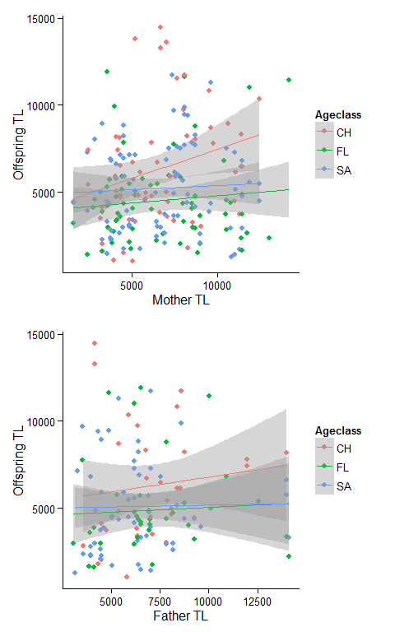

Run some models - In the first table, the same factors as before predict offspring telomere length, but so does maternal telomere length. In the second table nothing is significant. This could be collinearity, or it could be crappy sample size. Need to check.

## Estimate Std. Error t value Pr(>|t|)  
## (Intercept) 1.494574e+04 4.667682e+03 3.201963 0.00159039  
## mumTL 1.432307e-01 6.972421e-02 2.054246 0.04126557  
## AgeclassFL -1.608163e+04 9.439226e+03 -1.703702 0.09000562  
## AgeclassSA -1.887372e+04 8.724973e+03 -2.163184 0.03172520  
## Tarsus -4.244606e+02 1.966662e+02 -2.158279 0.03210974  
## Helper 1.657542e+03 7.543963e+02 2.197177 0.02916802  
## AgeclassFL:Tarsus 6.187923e+02 3.825467e+02 1.617560 0.10734940  
## AgeclassSA:Tarsus 7.466712e+02 3.543294e+02 2.107280 0.03635212  
## AgeclassFL:Helper -2.067862e+03 9.437672e+02 -2.191072 0.02961368  
## AgeclassSA:Helper -1.125955e+03 9.287468e+02 -1.212338 0.22682775

## Estimate Std. Error t value Pr(>|t|)  
## (Intercept) 1.661170e+04 6.255092e+03 2.6557082 0.009017652  
## dadTL 7.262270e-02 1.081893e-01 0.6712560 0.503380588  
## AgeclassFL -5.824188e+03 1.370184e+04 -0.4250660 0.671569311  
## AgeclassSA -1.276831e+04 1.162934e+04 -1.0979395 0.274485292  
## Tarsus -4.686498e+02 2.697034e+02 -1.7376487 0.084904005  
## Helper 1.223155e+03 1.180721e+03 1.0359390 0.302366986  
## AgeclassFL:Tarsus 2.198037e+02 5.564386e+02 0.3950188 0.693548246  
## AgeclassSA:Tarsus 4.905689e+02 4.754464e+02 1.0318071 0.304290636  
## AgeclassFL:Helper -1.796830e+03 1.478183e+03 -1.2155668 0.226597055  
## AgeclassSA:Helper -2.659164e+02 1.338856e+03 -0.1986147 0.842908882

Second, telomere length in both male and female parents is negatively related to the proportion of male offspring. So, mums and dads with longer telomeres have more female chicks.

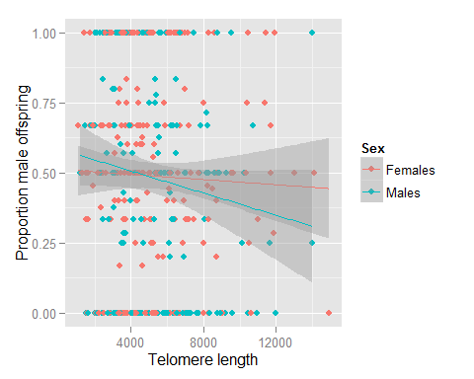

## Estimate Std. Error z value Pr(>|z|)  
## (Intercept) 0.3112073413 1.462015e-01 2.1286187 0.033285816  
## TL -0.0000667977 2.393978e-05 -2.7902382 0.005266928  
## SexMales 0.0562086048 1.191594e-01 0.4717092 0.637134356